Question 1:

We begin with the following steps:

1. Problem restatement

We have the system:

x + y \geq 9

6x + y \geq 15

x \geq 0

y \geq 0

We are to:

· Determine shape of feasible region: triangle, quadrilateral, or unbounded.

· List vertices in order: smallest x-value first, then smallest y if tie, then clockwise.

---

2. Interpret constraints

The inequalities are ≥, so feasible region is the intersection of half-planes above both lines x+y=9 and 6x+y=15, and in the first quadrant.

---

Intersection of x+y=9 and 6x+y=15:

From y = 9 - x and y = 15 - 6x:

9 - x = 15 - 6x

5x = 6

x = 1.2, \quad y = 7.8

Vertex: (1.2, 7.8)

---

Intersection with axes:

· x=0:

From x+y \geq 9 \Rightarrow y \geq 9

From 6x+y \geq 15 \Rightarrow y \geq 15

The binding one is y \geq 15 (more restrictive).

So along x=0, feasible y \geq 15.

Vertex: (0, 15) .

· y=0:

From x+y \geq 9 \Rightarrow x \geq 9

From 6x+y \geq 15 \Rightarrow 6x \geq 15 \Rightarrow x \geq 2.5

The binding one is x \geq 9 (more restrictive).

So along y=0, feasible x \geq 9.

Vertex: (9, 0) .

---

3. Shape of feasible region

The constraints x \geq 0, y \geq 0, x+y \geq 9, 6x+y \geq 15 define a region that extends infinitely to the upper-right direction (since both inequalities are lower bounds, no upper bounds on x, y).

Thus, shape = unbounded.

---

4. Vertices in required order

We have vertices from intersections of boundaries:

1. Intersection of x=0 and 6x+y=15: (0,15)

2. Intersection of x+y=9 and 6x+y=15: (1.2, 7.8)

3. Intersection of y=0 and x+y=9: (9, 0)

Also check intersection of y=0 and 6x+y=15: (2.5, 0) — but x=2.5 does not satisfy x+y \geq 9 when y=0, so not feasible.

So only 3 vertices: (0,15), (1.2, 7.8), (9,0) .

---

Order by smallest x:

· (0, 15) — smallest x = 0

· (1.2, 7.8) — next smallest x

· (9, 0) — largest x

---

Proceed clockwise from first vertex:

Plot points:

(0,15) → (1.2, 7.8) → (9,0) → back to (0,15) is counterclockwise? Let’s check:

Actually, going from (0,15) to (1.2,7.8) to (9,0) is clockwise around the bounded triangle that is part of the boundary, but the region is unbounded beyond (9,0) to infinity along x \geq 9, y=0 and beyond (0,15) upward along x=0.

But the problem says “vertices of the feasible region” — these are the extreme points of the feasible region, which are only these 3.

So:

First vertex: (0, 15)

Second vertex: (1.2, 7.8)

Third vertex: (9, 0)

Fourth vertex: blank

---

5. Final answer box

The shape of the feasible region is

unbounded

The first vertex is (0, 15)

The second vertex is (1.2, 7.8)

The third vertex is (9, 0)

The fourth vertex is ( ______ , ______ ) (leave blank)

---

So we conclude with the solution being Unbounded.

Vertices in order:

(0, 15),\ (1.2, 7.8),\ (9, 0)

Question 2:

1. Writing the equations in LaTeX

Let:

x = number of deluxe models

y = number of standard models

Constraints:

Production hours:

22x + 11y \leq 858

\]

Material units:

72x + 60y \leq 3480

\]

Non-negativity:

x \geq 0, \quad y \geq 0

\]

Objective function (Revenue):

R = 280x + 200y

\]

We want to maximize R .

---

2. Find corner points

From 22x + 11y \leq 858 :

Divide by 11:

2x + y \leq 78 \quad \Rightarrow \quad y \leq 78 - 2x

From 72x + 60y \leq 3480 :

Divide by 12:

6x + 5y \leq 290

Intersection of 2x + y = 78 and 6x + 5y = 290 :

From first: y = 78 - 2x

Substitute into second:

6x + 5(78 - 2x) = 290

\]

6x + 390 - 10x = 290

\]

-4x = -100 \quad \Rightarrow \quad x = 25

\]

y = 78 - 2(25) = 28

\]

Point: (25, 28)

Other corners:

· x = 0 : from 2x + y = 78 → y = 78 , check material: 6(0) + 5(78) = 390 > 290 → not feasible.

So from x=0 , use material constraint: 5y = 290 → y = 58 , check hours: 2(0) + 58 = 58 \leq 78 OK. So (0, 58) .

· y = 0 : from hours: 2x = 78 → x = 39 , check material: 6(39) + 0 = 234 \leq 290 OK. So (39, 0) .

· Origin (0, 0) .

Also intersection with axes:

From material constraint 6x + 5y = 290 , set y=0 → x = 290/6 \approx 48.33 , but hours constraint gives smaller x when y=0 , so binding is hours: x=39 when y=0 .

So feasible corner points:

(0, 0), \quad (39, 0), \quad (25, 28), \quad (0, 58)

3. Graph feasible set

We can plot:

y \leq 78 - 2x

y \leq (290 - 6x)/5

x \geq 0, y \geq 0

Intersection at (25, 28) .

Feasible region is a quadrilateral with vertices above.

4. Find corner that maximizes R = 280x + 200y

· (0, 0) : R = 0

· (39, 0) : R = 280 \times 39 = 10920

· (25, 28) : R = 280 \times 25 + 200 \times 28 = 7000 + 5600 = 12600

· (0, 58) : R = 200 \times 58 = 11600

Maximum at (25, 28) with R = 12600 .

So:

25 deluxe models, 28 standard models, max revenue $12600.

5. Introduce slack variables

Inequalities:

22x + 11y + s_1 = 858

\]

72x + 60y + s_2 = 3480

\]

x, y, s_1, s_2 \geq 0

Corner points in slack form:

· (0,0) : s_1 = 858, s_2 = 3480

· (39,0) : s_1 = 0, s_2 = 3480 - 72 \times 39 = 3480 - 2808 = 672

· (25,28) : s_1 = 858 - (22 \times 25 + 11 \times 28) = 858 - (550 + 308) = 858 - 858 = 0

s_2 = 3480 - (72 \times 25 + 60 \times 28) = 3480 - (1800 + 1680) = 3480 - 3480 = 0

· (0,58) : s_1 = 858 - 638 = 220 , s_2 = 0

6. Solve using built-in LP solver

Using scipy.optimize.linprog (minimization) so we minimize -R .

Code Snippet:

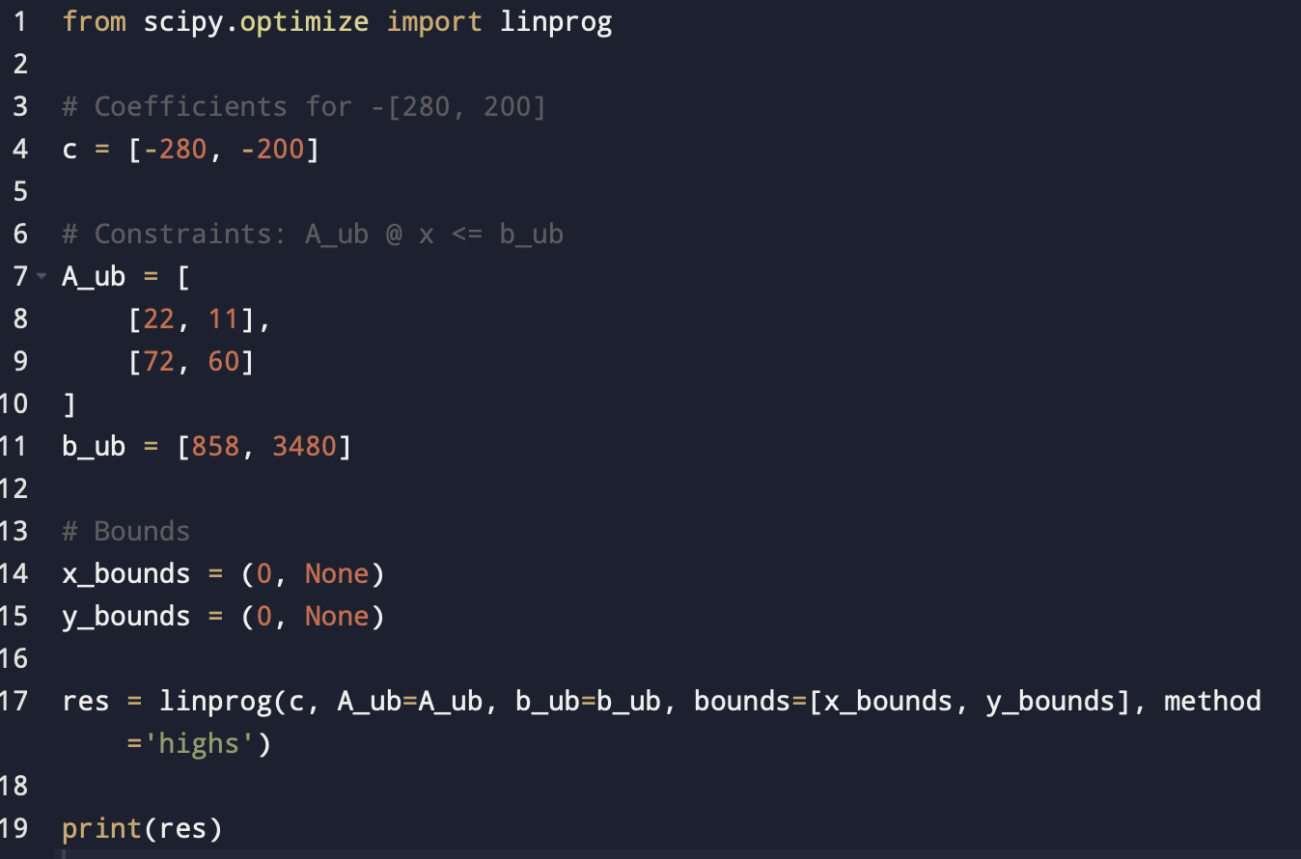

Output expected:

x = 25, y = 28, fun = -12600 (so max revenue = 12600).

Matches our earlier answer.

Final answer is : 12600

Produce 25 deluxe and 28 standard models.